Practice 1

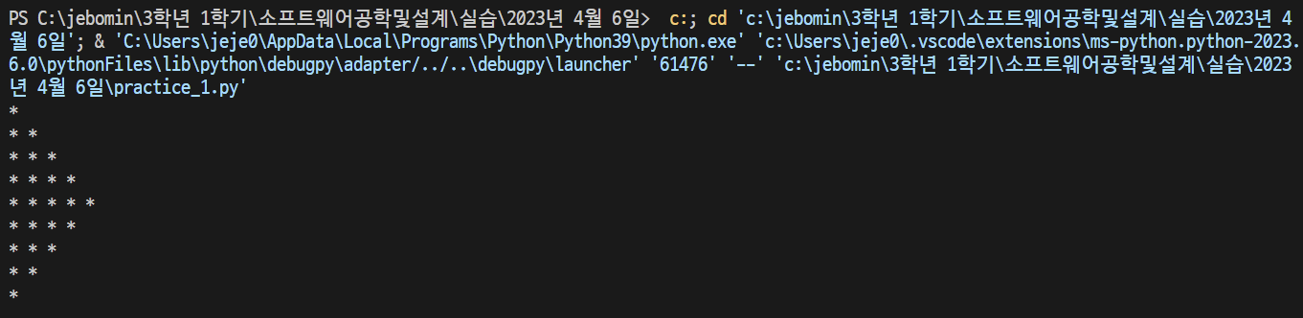

Practice 2

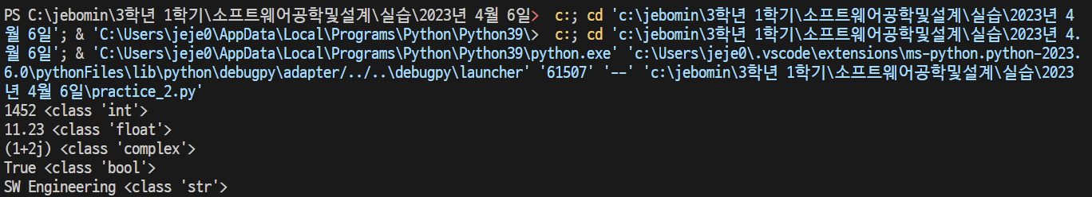

Practice 3

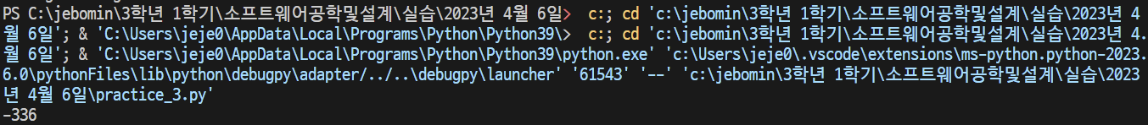

Practice 4

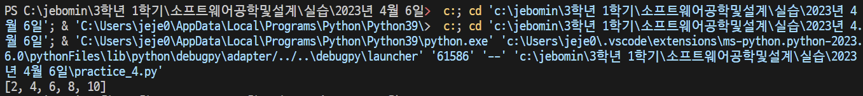

Practice 5

